1.introduction

* AND Gate

The AND gate plays an important role in the digital logic circuit. The output state of the AND gate will always be low when any of the inputs states is low. Simply, if any input value in the AND gate is set to 0, then it will always return low output (0).

The logic or Boolean expression for the AND gate is the logical multiplication of inputs denoted by a full stop or a single dot as

A.B=Y

The value of Y will be true when both the inputs A and B are set to true.

Types of Digital Logic AND Gate

The AND gate is classified into three types based on the input it takes. These are the following types of AND gate:

The 2-input AND Gate

This is the simple formation of the AND gate. In this type of AND gate, there are only two input values and an output value. There are 22=4 possible combinations of inputs. The truth table and logic design are given below:

**Logic Design**

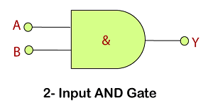

**Truth Table**

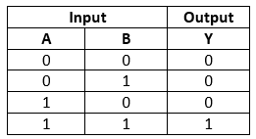

The 3-input AND Gate

Unlike 2-input AND gate, the 3-input AND gate have three inputs. The Boolean expression of the logic AND gate is defined as the binary operation dot(.). The AND gate can be cascaded together to form any number of individual inputs. There are 23=8 possible combinations of inputs. The truth table and logic design is given below:

**Logic Design**

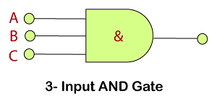

**Truth Table**

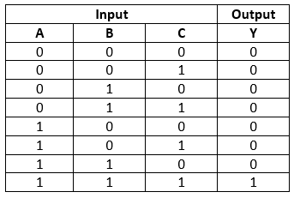

The Multi-input AND Gate

In digital electronics, we can form n-input AND gate also. If there are n inputs, then (N/2)+1 AND gates will be used.

**For example:**

If we have 6 inputs A, B, C. D, E, F, then 4 AND gates are used in the logic design of 6-input AND gate. There is the following expression of the 6-input AND gate:

Y = (A.B).(C.D).(E.F)

In simple words, it is expressed as:

Y=A AND B AND C AND D AND E AND F

**Logic Design**

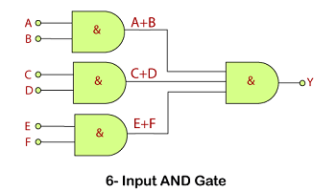

**Truth Table**

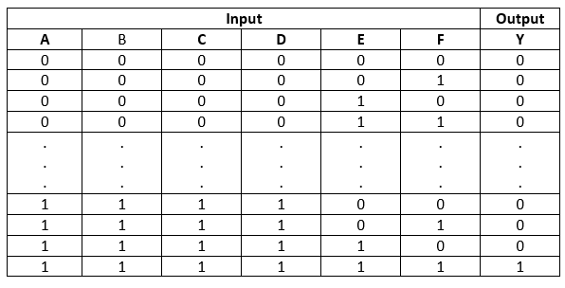

OR Gate

The OR gate is a mostly used digital logic circuit. The output state of the OR gate will always be low when both of the inputs states is low. Simply, if any input value in the OR gate is set to 1, then it will always return high-level output(1).

The logic or Boolean expression for the OR gate is the logical addition of inputs denoted by plus sign(+) as

A+B=Y

The value of Y will be true when one of the inputs is set to true

Just like AND gate, the OR gate is also classified into three types based on the input it takes. These are the following types of OR gate:

The 2-input OR gate

This is the simple form of the OR gate. In this type of OR gate, there are only two input values and an output value. There are 22=4 possible combinations of inputs. The truth table and logic design are given below:

**Logic Design**

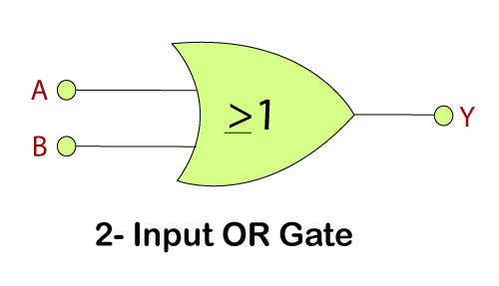

**Truth Table**

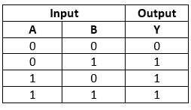

The 3-input OR gate

Just like AND gate, the OR gate can also have any number of individual inputs. The Boolean expression of the logical OR gate is defined as the binary operation plus(+). Like AND gate, OR gate can also be cascaded together to form any number of individual inputs. There are 23=8 possible combinations of inputs. The truth table and logic design are given below:

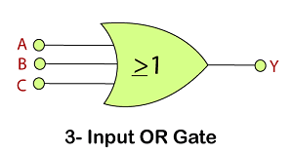

**Truth Table**

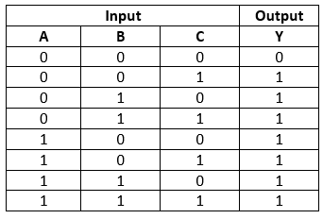

The Multi-input OR Gate

The n-input OR gate can also be formed. If there are n inputs, then (N/2)+1 OR gates will be used.

**For example:**

If we have 6 inputs A, B, C. D, E, F, then 4 OR gates are used in the logic design of the 6-input OR gate. There is the following expression of the 6-input OR gate:

Y = (A+B)+(C+D)+(E+F)

In simple words, it is expressed as: Y=A OR B OR C OR D OR E OR F

**Logic Design**

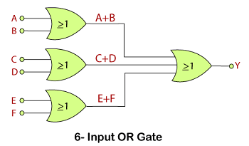

**Truth Table**

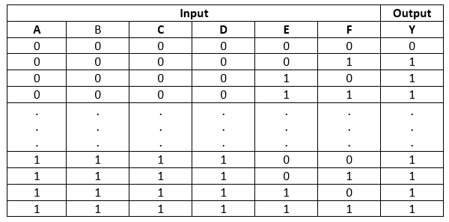

# Breadboard

A **breadboard**, **solderless breadboard**, or **protoboard** is a construction base used to build semi-permanent [prototypes](https://en.wikipedia.org/wiki/Prototype) of [electronic circuits](https://en.wikipedia.org/wiki/Electronic_circuit). Unlike a [perfboard](https://en.wikipedia.org/wiki/Perfboard" \o "Perfboard) or [stripboard](https://en.wikipedia.org/wiki/Stripboard), breadboards do not require [soldering](https://en.wikipedia.org/wiki/Soldering) or destruction of tracks and are hence reusable. For this reason, breadboards are also popular with students and in technological education.

A variety of electronic systems may be prototyped by using breadboards, from small analog and digital circuits to complete [central processing units](https://en.wikipedia.org/wiki/Central_processing_unit) (CPUs).

Compared to more permanent circuit connection methods, modern breadboards have high parasitic capacitance, relatively high resistance, and less reliable connections, which are subject to jostle and physical degradation. Signaling is limited to about 10 MHz, and not everything works properly even well below that frequency.

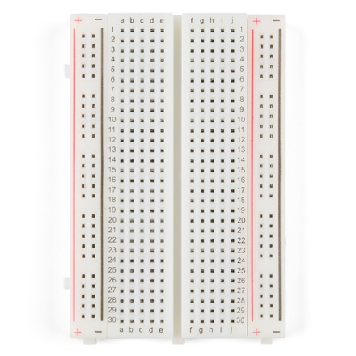

# Light-emitting diode

A **light-emitting diode** (**LED**) is a [semiconductor](https://en.wikipedia.org/wiki/Semiconductor) [device](https://en.wikipedia.org/wiki/Electronic_device) that [emits light](https://en.wikipedia.org/wiki/Light_source) when [current](https://en.wikipedia.org/wiki/Electric_current) flows through it. [Electrons](https://en.wikipedia.org/wiki/Electron) in the semiconductor recombine with [electron holes](https://en.wikipedia.org/wiki/Electron_hole), releasing energy in the form of [photons](https://en.wikipedia.org/wiki/Photon). The color of the light (corresponding to the energy of the photons) is determined by the energy required for electrons to cross the [band gap](https://en.wikipedia.org/wiki/Band_gap) of the semiconductor.[[5]](https://en.wikipedia.org/wiki/Light-emitting_diode#cite_note-5) White light is obtained by using multiple semiconductors or a layer of light-emitting [phosphor](https://en.wikipedia.org/wiki/Phosphor) on the semiconductor device.

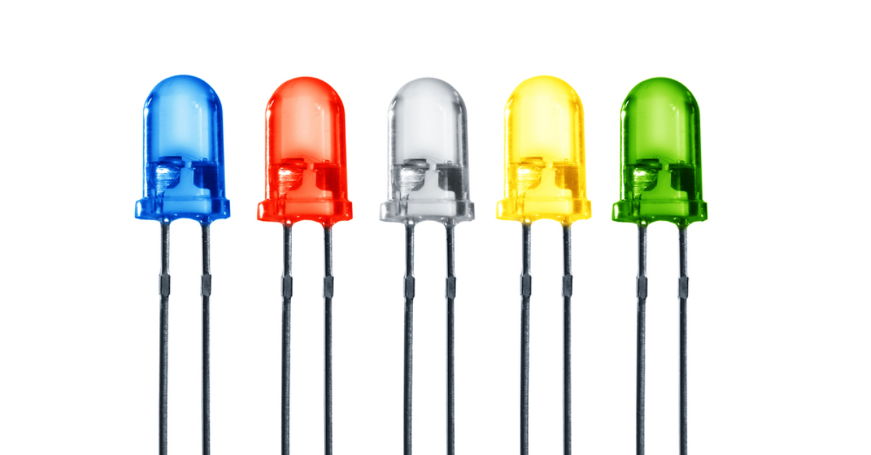

# Jump wire

A **jump wire** (also known as **jumper**, **jumper wire**, **DuPont wire**) is an [electrical wire](https://en.wikipedia.org/wiki/Electrical_wire), or group of them in a cable, with a connector or pin at each end (or sometimes without them – simply "tinned"), which is normally used to interconnect the components of a [breadboard](https://en.wikipedia.org/wiki/Breadboard) or other prototype or test circuit, internally or with other equipment or components, without soldering.[[1]](https://en.wikipedia.org/wiki/Jump_wire#cite_note-1)

Individual jump wires are fitted by inserting their "end connectors" into the slots provided in a breadboard, the [header connector](https://en.wikipedia.org/wiki/Pin_header) of a circuit board, or a piece of test equipment.

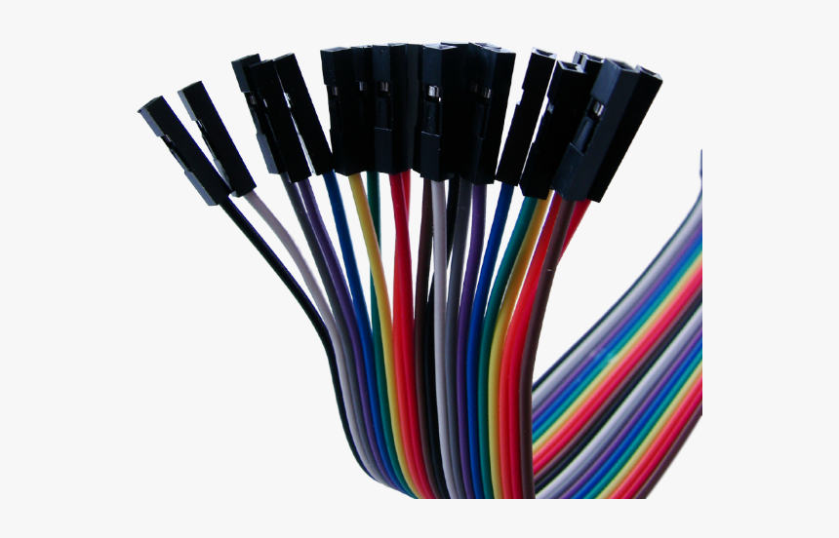

**IC 7408**

**IC 7408 is a logic gate IC**. It consists of four two-input AND Gates. The AND gate perform logical AND operation. Logic gates come in form of ICs. The all four AND gates are independent. Each gate has three pins two inputs and one output. IC 74HC08, IC DM7408 are AND gate ICs.

**Pin diagram of IC 7408:**

The IC 7408 has total fourteen pins including ground and Vcc. The simple pin diagram is shown below.  
The internal structure of IC 7408:

The internal structure of the IC 7408 is shown it consists of four AND Gates.  
[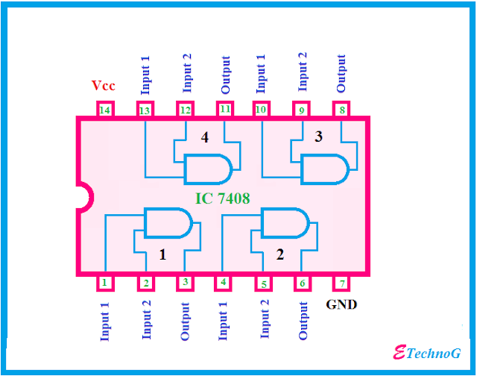](https://1.bp.blogspot.com/-8SEvhlfT89s/XFG_wCG9xuI/AAAAAAAABL4/oekBjN9BJNcT98MbAKcvSaQp2iWMi7s_gCLcBGAs/s1600/IC+7408+internal+structure.png)

Pin Description of IC 7408:

**Pin 1:** The pin 1 is the 1st input for 1st AND Gate.

**Pin 2:** Pin 2 is the 2nd input of 1st AND Gate.

**Pin 3:** Pin 3 is connected to the output of the 1st AND Gate.

**Pin 4:** Pin 4 is the 1st input of the 2nd AND Gate.

**pin 5:** Pin 5 is connected to the 2nd input of the 2nd AND Gate.

**Pin 6:** Pin 6 is connected to the output terminal of the 2nd AND Gate.

**Pin 7:** Pin 7 is the ground pin, it is used to provide power supply to the IC.

**Pin 8:** It is the output pin of the 3rd AND Gate.

**Pin 9:** It provides the 2nd input pin for the 3rd Gate.

**Pin 10:** It is the 1st input pin of the 3rd AND gate

**Pin 11:** Output of the 4th AND Gate.

**Pin 12:** It is connected to the 2nd input of the 4th Gate.

**Pin 13:** The pin 13 is connected to the 1st input of 4th Gate.

**Pin 14**: It is the Vcc terminal of the IC, it is used to provide the power supply to the IC chip.

IC 7432

**IC 7432 is a logic gate IC which** consist of four OR Gates. The OR gate performs logical OR operation. The OR gates come in form of  DIP package ICs. Each gate has three terminal two inputs and one output. The ICs are made by CMOS, TTL technology.

### Pin Diagram of IC 7432:

The IC 7432 has fourteen pins like other logic gates ICs. The pin diagram is shown below.

[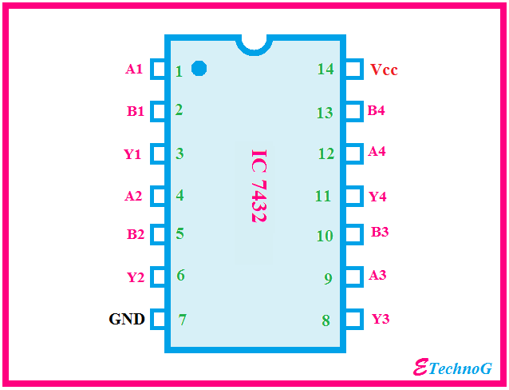](https://4.bp.blogspot.com/-QXkg2GHttuk/XFKJd3xgzgI/AAAAAAAABMI/PxWAf0DG1S8EJ1s4b4MXYBAWM04WRtWFQCLcBGAs/s1600/IC+7432+pin+diagram.png)

### Operating Condition of IC 7432:

* The power supply should be given to the IC from 4.5V DC to 5.25V DC
* The IC will consider a signal as high if the voltage of the signal is above 2V
* The IC will consider a signal as low if the voltage of the signal is below 0.8V
* The operating temperature of the IC should be below the 70-degree centigrade

#### Characteristics:

1. IC 74LS04 can deliver -0.4 mA current when the output is high.
2. It can deliver 16 mA current when the output is low.
3. When the Vcc is maximum and the input signal is 5V then the IC draws 1 mA current.
4. When the Vcc is maximum and the input signal is 2.7V then the IC draws 20 to 40 micro-ampere currents.
5. When the Vcc is maximum and the input signal is 0.4V  then the IC draws -1.6 mA current.

### The internal structure of IC 7432:

As I told before that the IC 7432 consist of four OR Gates, you can also see in the below figure.

The all OR Gates are independent.[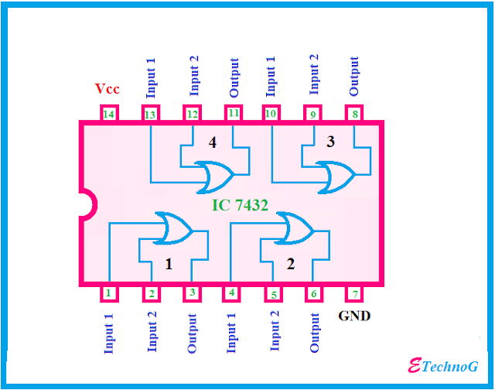](https://3.bp.blogspot.com/-Zx1WubKvq7I/XFKJroNHRkI/AAAAAAAABMQ/OwBp2JRnciAjFvMuOPSkgfVbSAJpIl7AgCLcBGAs/s1600/IC+7432+internal+structure.png)

Pin Description of IC 7432:

|  |  |
| --- | --- |
| **Pins** | **Description** |
| **Pin 1** | It is connected to the Input(A) of OR Gate 1 |
| **Pin 2** | Input(B) of OR Gate 1 |
| **Pin 3** | It is connected to the Output(Y) of OR Gate 1 |
| **Pin 4** | Input(A) of OR Gate 2 |
| **Pin 5** | Input(B) of OR Gate 2 |
| **Pin 6** | This pin provides the Output(Y) of OR Gate |
| **Pin 7** | Ground Pin which used to provide the power supply to the IC. |
| **Pin 8** | It is connected to the Output(Y) of OR Gate 3 |
| **Pin 9** | It is connected to the Input(A) of OR Gate 3 |
| **Pin 10** | Input(B) of OR Gate 3 |
| **Pin 11** | It is the output(Y) pin of the OR Gate 4 |
| **Pin 12** | It is the input(A) pin of the OR Gate 4 |
| **Pin 13** | It is the input(B) pin of the OR Gate 4 |
| **Pin 14** | It is Vcc pin which used to provide the power supply to the IC. |

battery

If there was ever an product that has been duplicated more than anything else in this world, this is it. We managed to get the original for our customers after sifting through a ton of Hi-Wattes and Hi-Wats.

It is an affordable, reliable, dedicated low-power solution to provide sufficient energy to your application. Ideally used in circuits with low power consumption so that it can work for longer durations.

**Features:**

* Model Number: 9V 6F 22
* Battery Type: Zinc Carbon
* Size: 6F22 006P
* Jacket: Metal
* Single Battery Dimensions (mm): L- 26. 5, H - 48. 5, W - 17. 5 (Max)
* Nominal Voltage(V) :9V
* Discharge Resistance(Ω): 620
* Cut-off Voltage(V): 5.4
* 